**App Title:**

Vaishya Digital Parichay Sammelan –Vaishya Patrika

**Description:**

Vaishya samaj Digital Parichay Sammelan - Vaishya Patrika - Vaishya Matrimonials

**Website URL:**   
https://shadibyah.com/socialapps/vaishyasamaj/

**Contact:**

[Yellowtech.lon@gmail.com](mailto:Yellowtech.lon@gmail.com)

**Interactive elements**

User interaction, online purchases

**Age rating**

Age rating from 18 years

**Android version required**

4.1 or higher

**Category**: SOCIAL NETWORK

**In-App Purchase**: Yes

**Advertisement**: No

**Permissions**: Camera, WiFi, Photos/Media, Storage

**App Description:**

**Aim to be largest Vaishya Matrimony Database in World**

Vaishya Samaj Digital Parichaya Sammelan is now available for Vaishya community across globe. Vaishya Patrika is the largest Online Matrimonial Platform dedicate to the Vaishya Samaj, Application is promoted by leading Social executives and designed to facilitate Vaishya families living in different part of India, UK, USA, Canada or any location worldwide.

We are the largest online matrimony patrika for **Vaishya Samaj with Aim to collect 50,000+** Vaishya profiles of Highly educated boys and Girls eligible for marriage. We invite all Vaishya families to download the application and share it to other families as well to take full advantage of this facility.

Use of application is very simple, Download the application by clicking the Install button and find the option to Register your Profile, Upload up to 3 of your latest photos of good quality. The application will later ask you to provide more details about you family background, Job details, Hobbies and Interest and finally the Partner preference. Once you create you partner preference, the application will provide you the correct match suitable and fits into your criteria.

**Vaishya Online Partika main features:**

- Free Registration for your perfect Shadi

- Upload up to 3 high quality photos and create a Photo album

- Search is simplified

- Search is automated as per your partner preferences defined in matrimony profile

- You will receive user ID and Password over SMS

- You can share you Profile ID to other to login and take a look so need to share the biodata physically

- Visit to our nearest office and take help of staff

- With vision to collect 50,000+ Vaishya profiles, you get largest choice

- Shadi is relationship of families for generations and we help to make it successful for you

Vaishya online Partika is designed to help all your matrimony need for the Vaishya bride AND Vaishya Groom, High qualified boys, Highly qualified girls, Vaishya NRI, Vaishya High Paid, Vaishya divorcee, Vaishya Manglik, Vaishya Widow, Vaishya Widower, Vaishya 40Plus, Vaishya defence at one place.

Vaishya boys and girls living in Mumbai, Bangalore, Hydrabad, Delhi, Pune, Chennai, Kolkata, Indore, Bhopal, Jaipur, Punjab, Rajasthan, Madhya Pradesh, Maharashtra and working in different high qualified professional jobs including IT Manager, Software Engineer, Working abroad, CA, CS, ICWA, Management Positions, Business Owner, Artists, Government Jobs, IAS, IPS etc.

Please ensure you download this Free application today and make sure you spread the application to every Vaishya family in your contacts and help us building this largest Vaishya database on earth

**Images:**

Mobile Home Page (Delay 3 seconds)   
500PX (W) X 1000 PX (H)

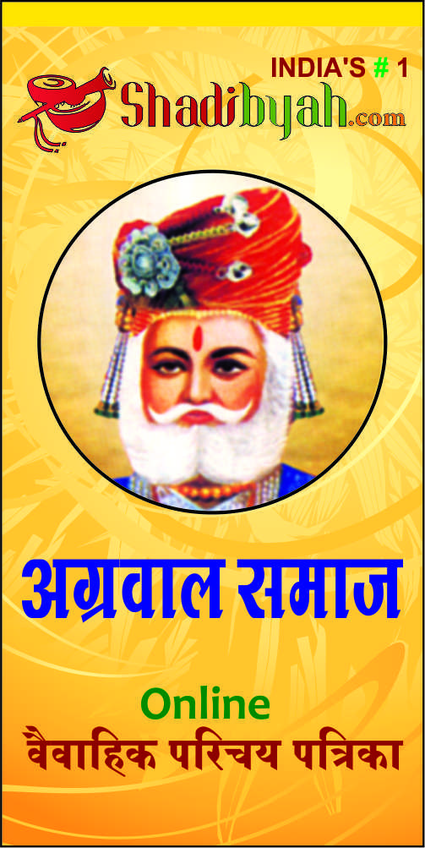

Mobile application Logo Image   
Size: 500PX (W) X 500PX (H)

